INTRODUCTION OF INFOSYS LIMITED
Infosys Limited is a leading global IT consulting and services company headquartered in Bengaluru, India, founded in 1981 by seven engineers led by N.R. Narayana Murthy. As the second-largest Indian IT firm by revenue, it specializes in digital transformation, AI-driven solutions, and outsourcing for1,900+ clients across 59 countries
KEY ASPECTS OF INFOSYS COMPANY
1. Business Activities
Provides IT services, consulting, and business solutions.
Main services include software development, cloud computing, digital transformation, AI, and outsourcing services.
2. Global Presence
Operates in 50+ countries with offices and development centers worldwide.
Serves clients in industries like banking, healthcare, retail, manufacturing, and telecom.
3. Workforce
Employs hundreds of thousands of professionals globally.
Known for strong employee training and development programs.
4. Financial Strength
Listed on the National Stock Exchange of India and Bombay Stock Exchange.
One of the largest IT companies in India by revenue and market value.
6. Corporate Governance
Recognized for strong corporate governance, transparency, and ethical business practices.
7. Innovation and Technology: Invests heavily in research, digital technologies, artificial intelligence, and automation to improve services.
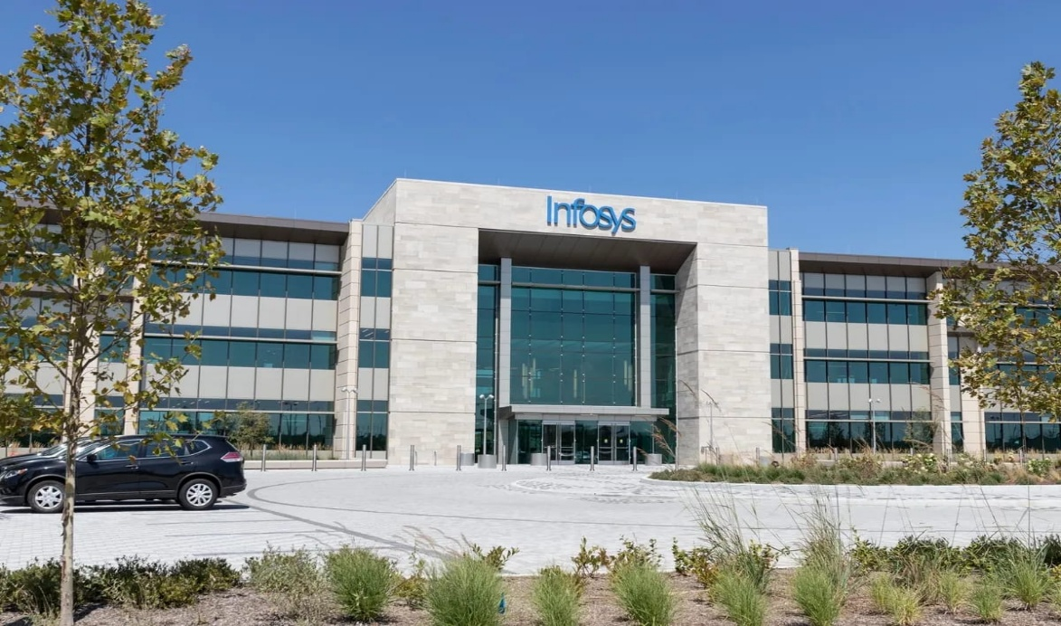
NATURE OF BUSINESS
1. Information Technology Services
Infosys Limited mainly provides IT services and software solutions to businesses around the world.
2. Consulting Services
The company offers business and technology consulting to help organizations improve efficiency and adopt digital technologies.
3. Software Development
Infosys develops custom software applications for clients in industries such as banking, healthcare, retail, and telecom.
4. Digital and Cloud Services
It provides digital transformation, cloud computing, data analytics, and artificial intelligence solutions.
5. Business Process Management (BPM)
Through its subsidiary Infosys BPM, the company offers outsourcing and business process services.
6. Global IT Solutions
The company serves clients in many countries and provides technology solutions, maintenance, and support services worldwide.
OBJECTIVE OF THE STUDY
1. To analyse the financial performance of the company using ratio analysis.
2. To evaluate the profitability, liquidity, solvency and efficiency position of the company.
3. To study the financial strengths and weaknesses of the organisation.
4. To understand the company's operational efficiency through financial data.
5. To compare the performance of the company over the last three years (FY 2023, FY 2024, FY 2025)
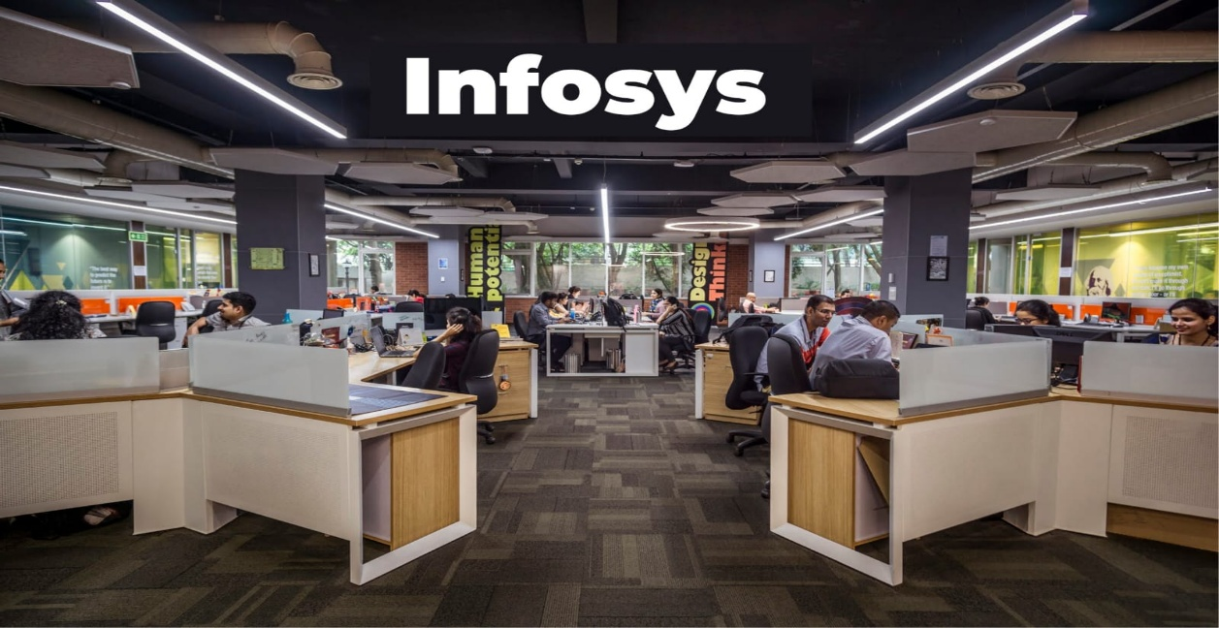
6. To assist management and stakeholders in financial planning and decision-making.

